

ITA0330-Mobile Computing

Name: T. Dharani Devi Reg no:192425036

Slot: D Course Name: Mobile Computing

Experiment 5: Localization-Based Mobile Application
Aim: To design a wireframe for a mobile application incorporating localization features using Figma.
Procedure:
- Open Figma and create a new design file.
- Select a smartphone frame for the application.
- Design a home screen with a location search bar.
- Add a map showing the user's current location.
- Include nearby places, route navigation, and location details.
- Add location permission and settings options.
- Use Prototype mode to connect the screens and test navigation.
Output:
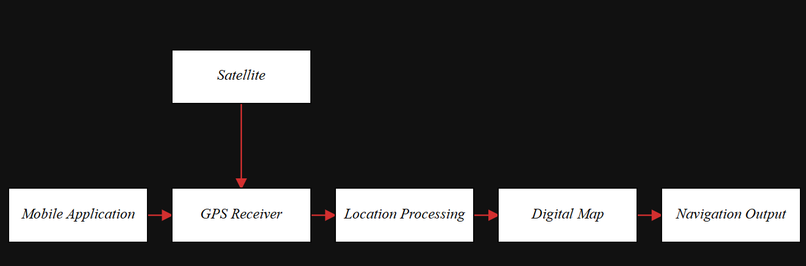

https://www.figma.com/make/k9Zgf520XlpTl5AvzCWiaM/EXPERIMENT-5?t=EgmerP76fgHXnljb-0
Result: Thus, a wireframe for a localization-based mobile application was designed successfully using Figma.

